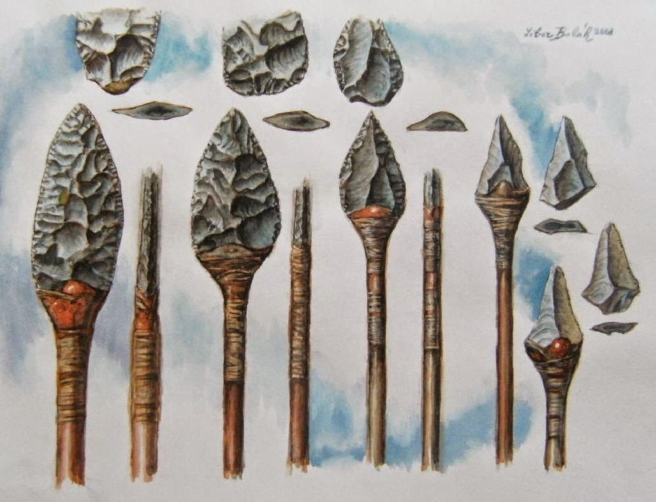

http://imgkid.com/neanderthal-tools-and-weapons.shtml

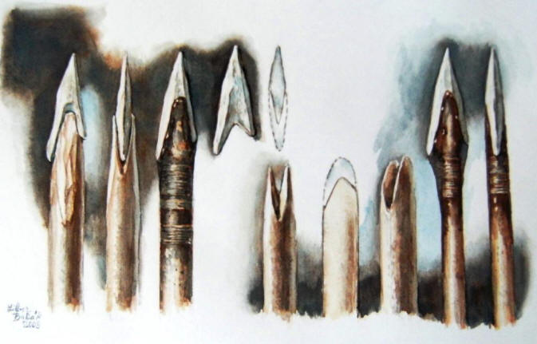

http://imgarcade.com/1/neanderthals-tools-and-weapons/

interesting info to read:

http://www.google.de/imgres?imgurl=http%3A%2F%2F1.bp.blogspot.com%2F-b_epRqV4-bg%2FVAZ85iHLixI%2FAAAAAAAAAjA%2Fr2FVli6kt38%2Fs1600%2Fprehistoric%25252Bclothing%25252Band%25252Btools%2C%25252Bfound%25252Bon%25252BEmmanuel%25252BRoudier%2527s%25252BNeanderthal%25252Bblog%2C%25252Band%25252Bpresumably%25252Bby%25252Bhim.jpg&imgrefurl=http%3A%2F%2Fantiquatedantiquarian.blogspot.com%2F2014_09_01_archive.html&h=1282&w=1600&tbnid=X3vdWUshy4QDhM%3A&zoom=1&docid=pz1p0N6_2xvKSM&ei=iOL-VLDsJMTzPPuPgIAJ&tbm=isch&iact=rc&uact=3&dur=758&page=1&start=0&ndsp=44&ved=0CHwQrQMwHQ